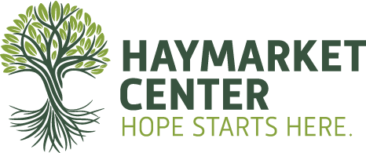

2021 Fall Workshop Series
Sept 18th-Dec 4th
# of Workshops | General Admission | Student/Senior Discount
1 | $80 | $70
2 | $125 | $115
3 | $195 | $170
4 | $260 | $220
5 | $300 | $230
6 | $390 | $340
7 | $450 | $400
8 | $500 | $460
9 | $580 | $500
10 | $625 | $570

Please select which workshops you plan to attend:

□ A September 18, 2021 - Emotional Management for Women in Recovery
□ B September 25, 2021 - Made a Searching and Fearless Moral Inventory of Ourselves: Addressing
Structural Racism Within America’s Mental Health System
□ C October 2, 2021 - Addiction State of the Union 2021
□ D October 9, 2021 - Slipping Through the Cracks: Intervention Strategies for Clients
with Multiple Addictions and Disorders
□ E October 16, 2021 - The Impact of the Multigenerational Transmission of Mental Illness/Substance
Abuse on African American Families
□ F October 23, 2021 - Systemic Racial Trauma and Somatic Healing Concepts
□ G November 6, 2021 - Liberating Our Patients and Ourselves: A Decolonizing Approach to
Treating Addiction, Trauma and Historical Trauma
□ H November 13, 2021 - Approaching Clinical Work with Clients in the LGBTQIA+ Community
□ I November 20, 2021 - Motivational Interviewing and Cultural Responsiveness:
Evidence-Informed Strategies for Multicultural Practice
□ J December 4, 2021 - The Power of Being Enough: Connection, Identity, and
Attachment in Recovery

Please select your registration type:
□Individual Rate □Student Rate □Senior Rate

Registrant Contact Information:

Name: _______________________________________________________________________________________________
Address: _____________________________________________________________________________________________

City: ________________________________________________________________ State: ________ Zip: _____________
Company: ____________________________________________________________________________________________
Email: ________________________________________________________________________________________________
Phone Number: ______________________________________________________________________________________

Payment Information: □ Credit Card □ Check Enclosed

Credit Card Number: __________________________________________________________________________________

Expiration Date: __________________ CSV: ___________ Zip Code: ___________

Please email this form to labrams@hcenter.org or mail to:
Haymarket Center
Attn: Lisa Abrams
932. W. Washington
Chicago, IL 60607

For more information about the Summer Institute, contact Lisa Abrams at labrams@hcenter.org
or call (312) 226-7984 ext. 581.

